1. Any software capable of doing following 3 things is called Server.  
   **Server** = Software + Hardware
2. Hotel or Resturant Server (Waiter)  
   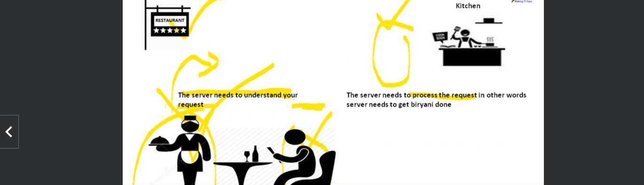  
   Server takes request.  
   Make it processed in the Kitchen.  
   Get the food to the table.
3. Now taking the example from Software Field.  
   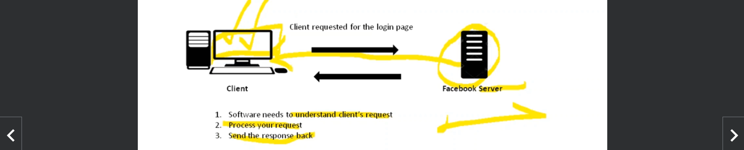
4. 
5. Yes.